DAT602
Declan Dover

Assessment 1
GUI to database PROTOTYPE

1. Game Overview 3
2. Graphical Design 3
2.1. Login Page 3
2.2. Account Registration Page 4
2.3. Main Form 5
Requirements: [3] 5
2.4. Admin Tools 6
Requirements: [11], [12], [13], [14] 6
2.5. Game Board 8
Requirements: [4], [5], [6], [7], [8]. [9], [10] 8
3. Entity Relationship Diagram 9
3.1. ERD 9
3.2. Rationale 9
3.2.1. User 9
3.2.2. Mouse 9
3.2.3. Game 10
3.2.4. Inventory 10
3.2.5. Tile 10
3.2.6. Mousetrap 10
3.2.7. Message 10
3.2.8. Cheese 10
3.2.9. Cat 11
4. CRUD Table 12
4.1. Notes 13
5. DDL and Test Data 13
5.1. DDL 13
5.2. Test Data 13

1. Game Overview

The game will be a point and click game where players are mice moving around on a grid collecting cheese for points. The game will also allow players to collect mouse traps that enter the players inventory and allow them to place them around the grid to catch other players. The game will feature an NPC that is a cat moving randomly around the grid. If a player collides with the cat they will lose one cheese and return to the starting tile. The first player to collect ten cheese pieces wins the game.

The game will have a login screen allowing players to log in or create an account, a list of active games, and options to host a new game. Games can have up to 12 players at a time and movement is in real time with locations updating each 0.5 seconds. A separate admin GUI will exist for admin accounts with options to add new players, end current games, update player data, and remove existing players.

2. Graphical Design

2.1. Login Page

Requirements: [1]
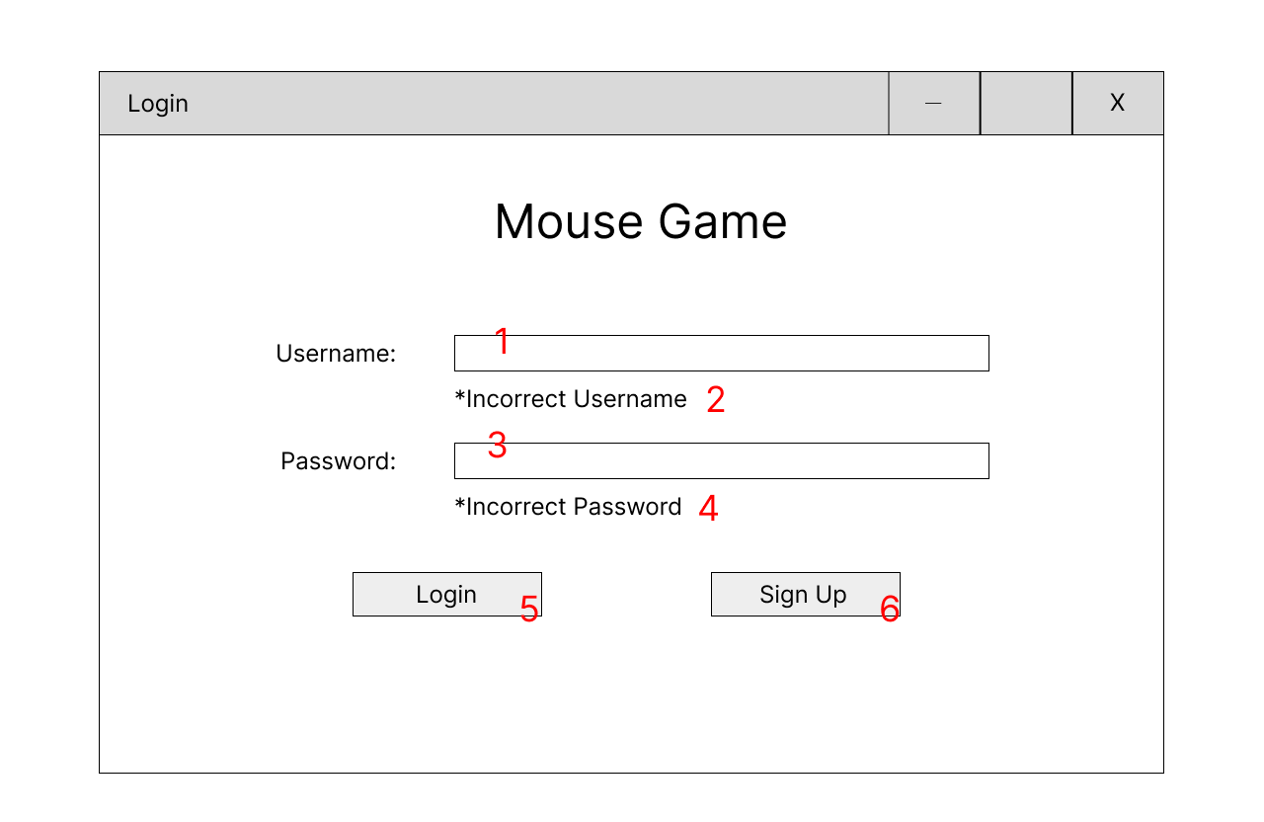
- The player enters their username in the username text box,

- If the username is not found the ‘Incorrect Username’ text is displayed

- The player enters their password in the password text box

- If the password is incorrect the ‘Incorrect Password’ text is displayed

- The Login button logs the player in if the details are correct. If incorrect details are entered too many times the button will become grayed out and inactive with a message displaying this to the user as well as a contact email for the admin. After a successful login the user is taken to the main form. The login details are sent to the database and checked against the list of registered users.

- If the user clicks sign up they are taken to the account registration page

2.2. Account Registration Page

Requirements: [2]
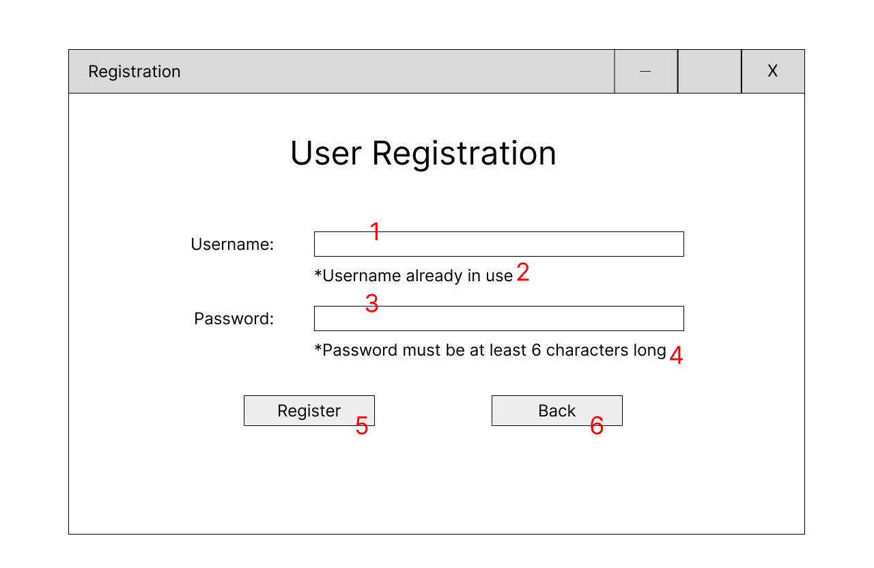
- The player enters their desired username in the Username text box

- If the username is already in use, text is displayed indicating this to the user

- The user enters their desired password in the password text box

- If the desired password doesn’t meet the requirements a message is displayed to the user

- If the username and password pass validation, clicking register creates the new account and takes the user to the log in page. The new account details are added to the account table in the database.

- The back button returns the user to the login page without creating a new account

2.3. Main Form

2.4. Requirements: [3]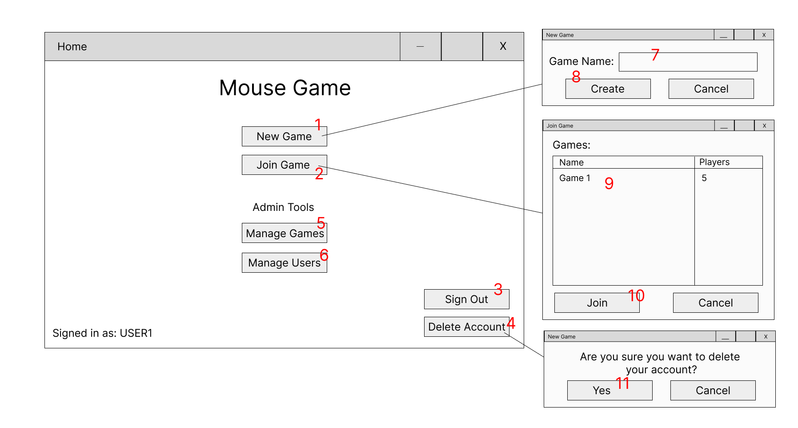
- If the user clicks the ‘New Game’ button the new game form is opened

- If the user clicks ‘Join Game’ the join game form with the list of current games is opened. The list of games is retrieved from the game table in the database.

- Clicking ‘Sign Out’ logs out the user and returns them to the login screen

- Clicking ‘Delete Account’ opens a confirmation dialogue for account deletion

- The ‘Manage Games’ button appears only to admin users

- The ‘Manage Users’ button appears only to admin users

- When creating a new game the user enters a game name into the text box

- Clicking create starts a new game and takes the user to the game form. A new entry is added to the game table with the name given in the text box.

- The join game form contains a list of active games and the amount of players in each one. The user can select one of these games from the list

- Clicking ‘Join’ with a valid game selected places the user in that game and opens the game form. A new entry is added to the player table referencing the account and the room that has been joined.

- Clicking ‘Yes’ on the confirmation dialogue deletes the user's account and returns them to the login form. The account is then removed from the account table in the database.

2.5. Admin Tools

2.6. Requirements: [11], [12], [13], [14]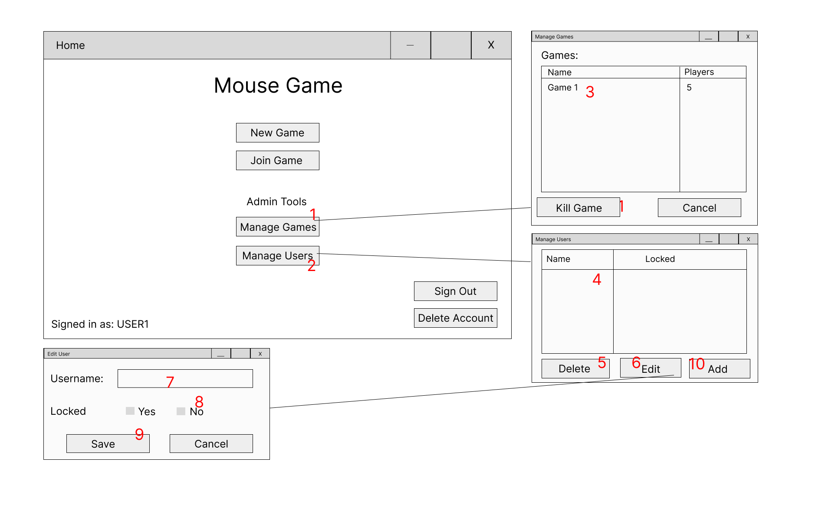
- If an admin user is logged in, the user may click the ‘Manage Games’ button to bring up the game list form and the management options.

- If an admin user is logged in, the user may click the ‘Manage Users’ button to bring up the user list form.

- The manage games form brings up a list of all active games, the user can select a game and click the ‘Kill Game’ button to terminate that game after a confirmation dialogue. Killing a game removes it from the game table in the database as well as removing any associated entries.

- The manage users form has a list of all user accounts, the user can select an account from the list and click one of the management buttons. The user list is retrieved from the account table in the database. The list displays the username and whether the account is locked.

- The ‘Delete User’ button removes the selected user account after a confirmation dialogue. The corresponding entry is removed from the account table in the database.

- The ‘Edit’ button brings up the edit user form, filled with the selected user’s information

- The user can enter a new username for the selected user in the username text box. This updates the account in the database

- The admin user can change the locked status from yes to no to unlock the account, this updates the account in the database

- If the new username and email pass validation the user can save the new details with the ‘Save’ button. These values are then updated in the user table within the database.

- The ‘Add’ button takes the user to the registration page to add a new user

2.7. Game Board

2.8. Requirements: [4], [5], [6], [7], [8]. [9], [10]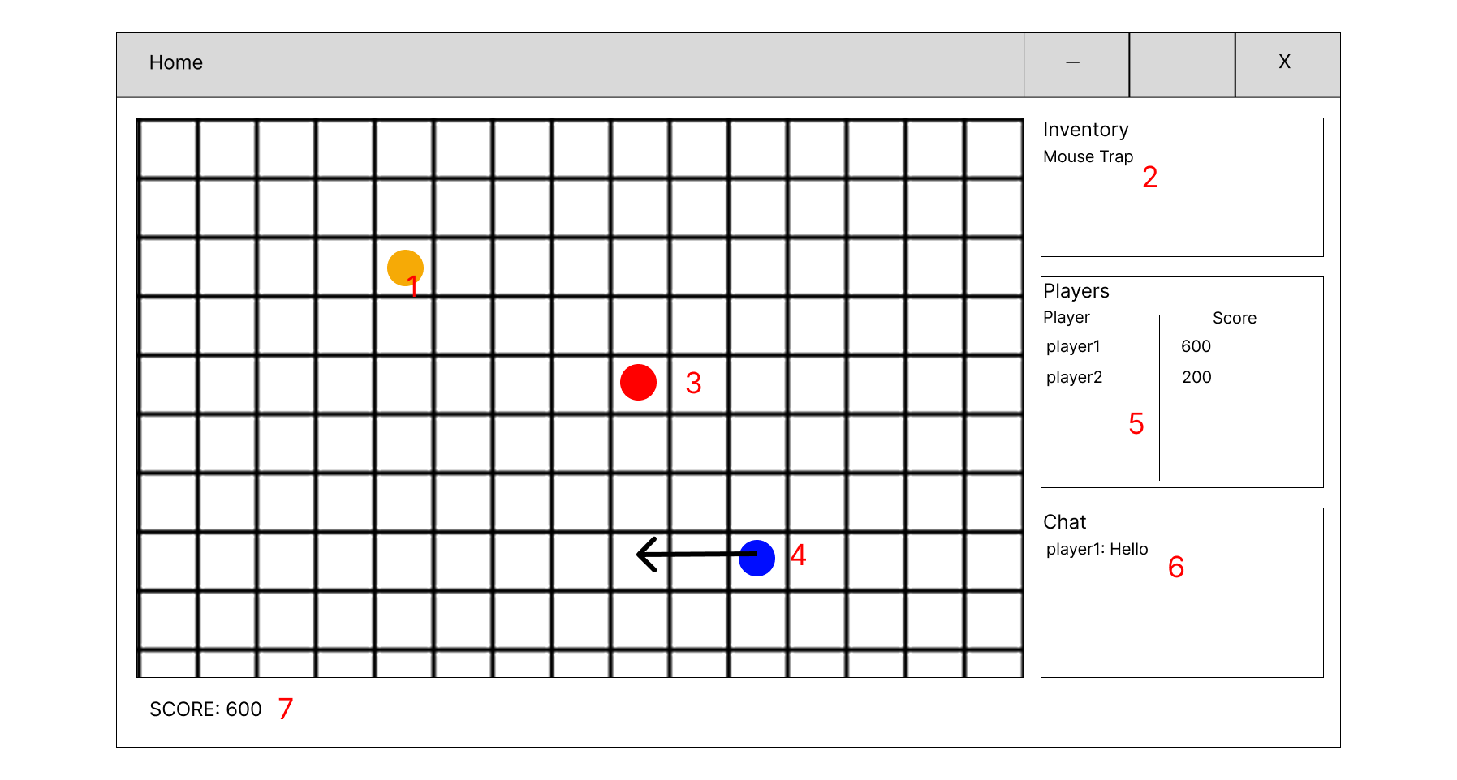
- When a new game board form is opened the board is filled with tiles. Cheese is placed randomly on the tiles around the board. Collecting cheese adds 100 points to a player's score. When a cheese appears on the board an entry is created in the item table in the database.

- The player's inventory is displayed on the right hand side, after moving onto a tile with an item on it, that item is removed from the board and added to the player’s inventory list. The item is then removed from the item_tile table and an entry is created in the player_item table.

- The player begins in the center tile of the board, the ‘home tile’, the player can click any adjacent tile to move onto that tile, and can move around the board this way. When the player moves to a new tile the tile_id attribute of that player in the player table is updated.

- A cat NPC randomly moves around the board, if the NPC comes into contact with a player, that player loses 100 points and is removed from the game for seconds before reentering at the home tile.

- The player list shows all the players currently in the game and their current scores

- Clicking the chat section allows the player to type a message which is then displayed to all other players in the current game within the chat window. The messages are added as an entry to the message table in the database, with a player_id, timestamp, and room_id.

- The player’s current score is displayed at the bottom left of the form. Reaching 2000 points causes a player to win the game and the game is over. When a game is over the game is closed and removed from the game table.

3. Entity Relationship Diagram

3.1. ERD
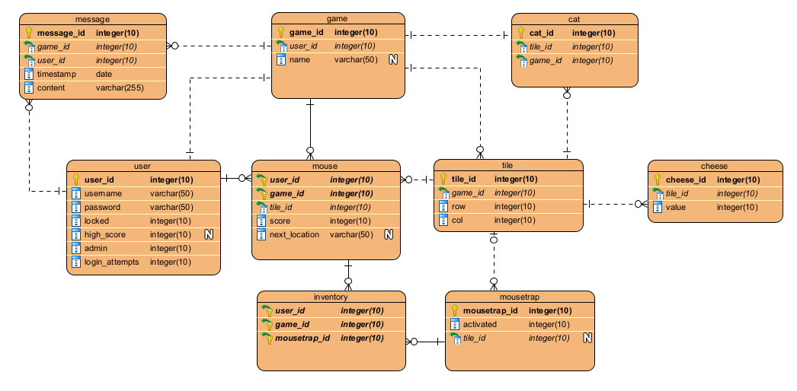

3.2. Rationale

3.2.1. User

The user entity contains account level player identities. Each user account is a single row in the table. It has username and password attributes, a locked attribute that will be 0 by default and change to 1 if an account is locked, a players highest score they have achieved in a game, the players login attempts, default zero and increasing by 1 each time they unsuccessfully log in with a maximum of 5 before the account is locked, and an admin attribute, 0 for a non admin and 1 for an admin.

3.2.2. Mouse

The mouse entity is an instance of a player within a game, it has a composite primary key of user_id and game_id, representing the user that is controlling the mouse and which game the mouse is in. The tile_id foreign key references the tile they are currently on, and the next_tile attribute will hold the id of the tile the player has clicked to move to. The score attribute holds the current score the player has in the game they are in.

3.2.3. Game

The game entity represents a game that is currently running. It has a user_id foreign key referencing the user that created the game and a name attribute which is the display name the user chose for the game when creating it.

3.2.4. Inventory

The inventory entity represents a joining table between mouse and mousetrap. The table has three foreign keys forming a composite primary key. User_id and game_id represent the mouse that holds the item, and mousetrap_id represents a mousetrap in their inventory.

3.2.5. Tile

The tile entity represents a tile on a game board. Each tile has a primary key tile_id, a foreign key game_id that references a game to keep track of what game the tile is in, and a row and column attribute that represent where on the game board the tile exists.

3.2.6. Mousetrap

The mousetrap entity represents a mousetrap item that is either on a game board or in a player's inventory. If the mousetrap is on a game board it will have a tile_id attribute referencing a tile it is on. Tile_id will become null when the mousetrap is picked up, and when a player places the mousetrap on the board again the tile_id will be updated with its new location. The mousetraps activated attribute represents whether the mousetrap is available to be picked up or has been placed by a player on the board.

3.2.7. Message

The message entity represents a message in a game's chat room. It has a primary key of message_id. The message has a game_id foreign key that references which games chatroom it was written in, a user_id foreign key referencing the user that wrote the message, a timestamp attribute with the time it was posted in order to display the messages in the correct order, and a content attribute containing the actual message.

3.2.8. Cheese

The cheese entity represents a cheese on a game board. It has a cheese_id primary key. It has a foreign key, tile_id referencing the tile it exists on, and a value attribute which holds the amount of points to be added to a player's score when picked up. This value attribute exists for the case of different value cheese types being added in a future iteration.

3.2.9. Cat

The cat entity represents the NPC cat that moves around the board. It has a primary key of cat_id, a foreign key game_id referencing the game it is in, and a tile_id referencing its location on the board. The one-to-many relationship with games exists in the case of allowing for multiple cats in a game in a future iteration.

4. CRUD Table
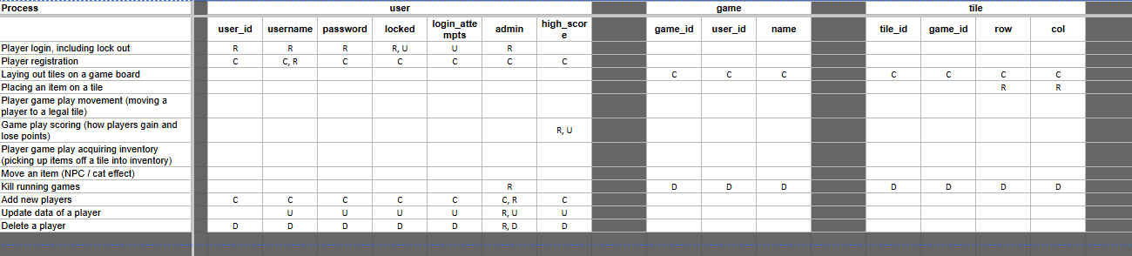
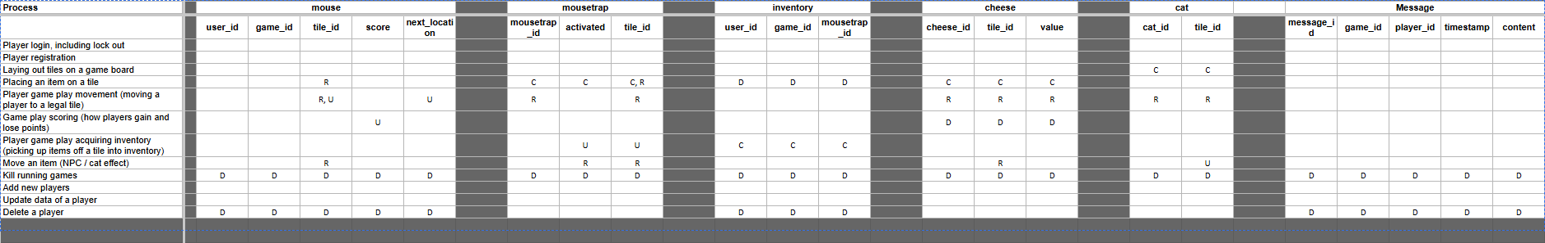

4.1. Notes

Cheese is deleted on pickup as they exist only as a way of adding to the player’s score. The other item, mousetrap, moves between the tile and the player’s inventory and therefore only its tile_id is updated to null upon pickup and then updated again once placed.

Collision detection is represented through any movement or item placing process reading the tile_id attribute of the other entities, this prevents two things existing on the same tile.

Cascading deletes exist when deleting a user for their mice, messages, and inventory. Games hosted by the deleted user are not affected. The same applies for when games are killed, all objects and tiles in that game are also deleted to prevent orphaned rows in these tables.

login_attempts is read each time a player tries to log in and updated. A successful login resets the login attempts to 0 whereas 5 attempts updates the ‘locked’ attribute.

Message is only affected by the killing game process, which deletes all of the messages linked to that game. Messages would be created when sent by a player and the message table would be read each time the game UI refreshes.

5. DDL and Test Data

5.1. DDL
The create table statements, constraints, and inserts for test data are all contained in a single CreateTables() procedure. The tables are created according to my ERD and the foreign key constraints are added in alter table statements in order to name the constraints consistently for any future debugging. Foreign key constraints are turned off at the start of the procedure to prevent any errors when inserting data with references to data that is not yet inserted and then are turned back on at the end of the procedure. The inserts for the tile table use while loops to generate a 12x12 grid with correct row and col attributes as well as AUTO_INCREMENT for its tile_id attribute.

5.2. Test Data
Test data was inserted into each table in order to represent a case for all the CRUD processes from the table. The data for the user includes an admin user and a locked user. The data for mousetrap includes non-activated mousetraps on the game board, an activated mousetrap on the game board, and mousetraps that are in players inventories with a tile_id of NULL. The test data has one active game, a tile for every space on this game board, four mice currently in the game, 2 cheese items on the game board, one message in the game chat, and a cat NPC.

Milestone 2

6. Testing Interactions and Handlers

1. Player login, including lock out

Logging in calls the Login method from AdminDAO and is passed the username and password that are entered. The method returns a string with the status of the log in that can be displayed to the user

A login with correct credentials moves the user to the main form

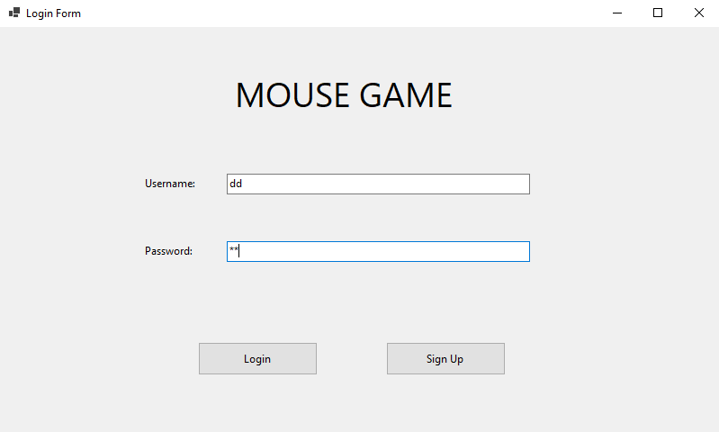

Incorrect credentials display a simple message, in the final version this message will be more elaborate

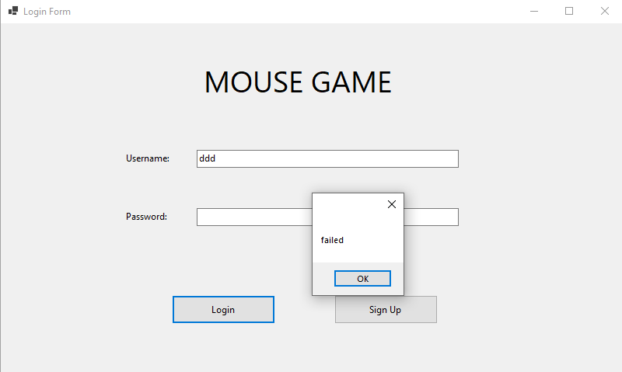

Multiple incorrect passwords on a valid username result in a lockout

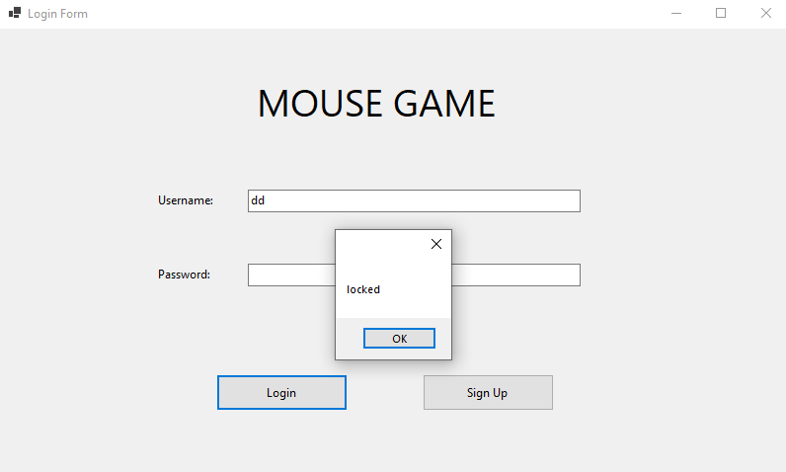

2. Player registration

Registration happens on the registration form

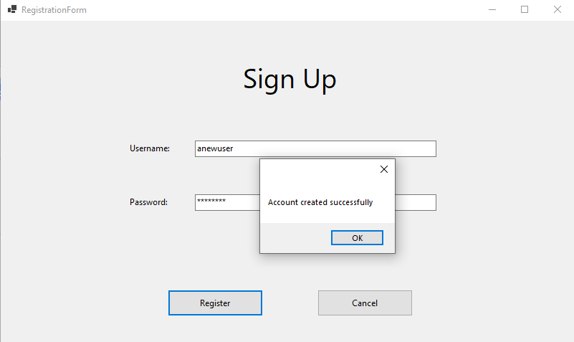

The registration form calls Register within the AdminDAO and passes it the entered username and password. The new user is created successfully

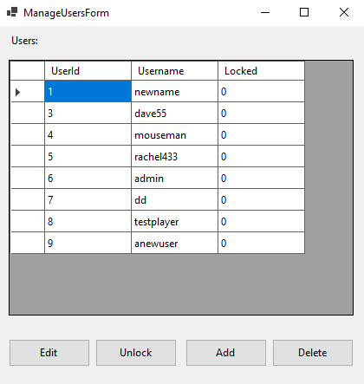

3. Laying out tiles on a game board

Opening a game form lays out the game tiles, represented by picture boxes. Upon opening a form the GetTilesForGame method within GameDAO is called and is passed the ID of the game. This method then maps each picture box to the tile row in the tile table that it represents using its tile ID.

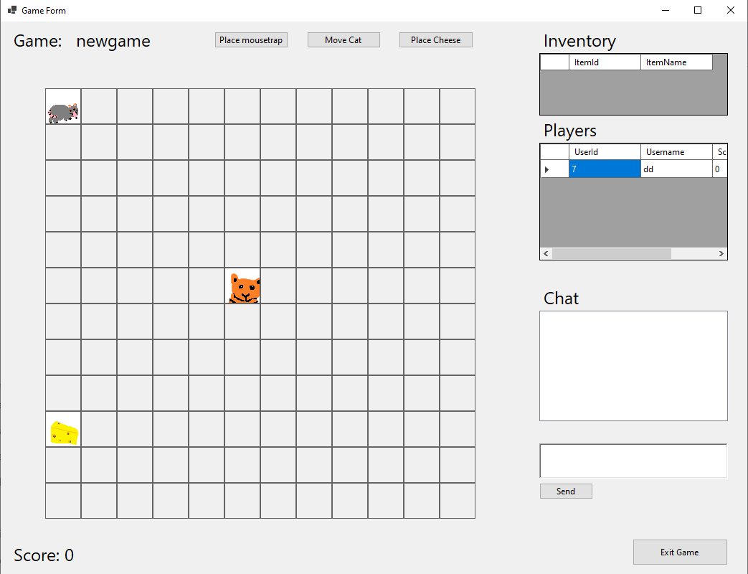

4. Placing an item on a tile

The buttons on the game form place cheese and mousetraps, in a future version these will be placed regularly with a timer. These buttons call the PlaceCheese and PlaceTrap methods within the GameDAO. Each passes the game ID of the game they are clicked in to the method.

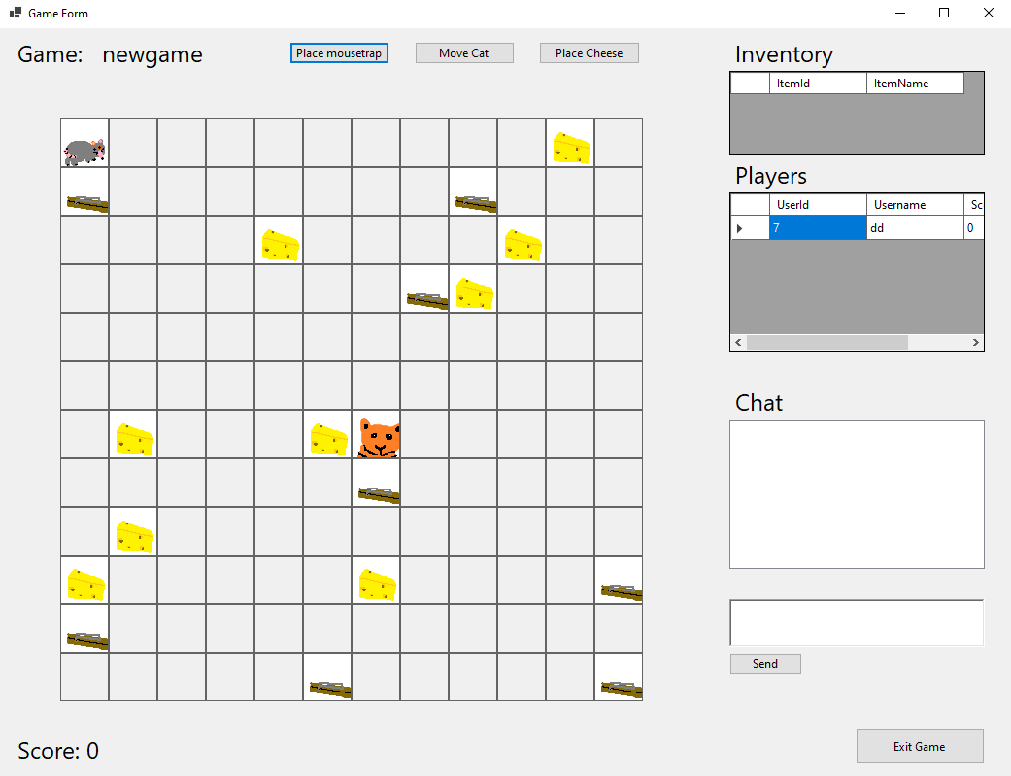

5. Player game play movement, i.e., moving a player to a “legal” tile
Clicking an adjacent tile moves the players mouse around the board. The tile ID of the tile that is clicked as well as the user ID and game ID are passed into the MovePlayer method within the GameDAO

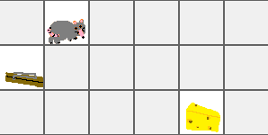

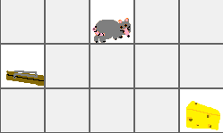

Clicking a non adjacent tile or one occupied by another mouse has no effect

6. Game play scoring. How do players gain and lose points?
Moving onto a cheese adds 100 score to the players score, this happens when the MovePlayer method is called within the GameDAO

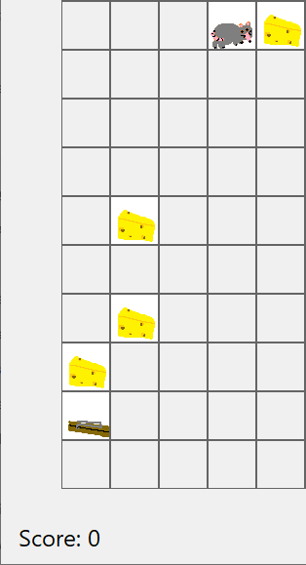

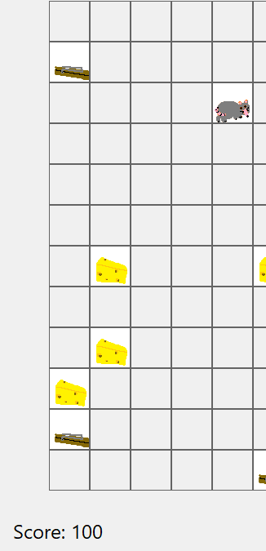

7. Player game play acquiring inventory, e.g., picking up items off a tile and putting them in an inventory (bag?)
Moving onto a mousetrap adds it to the players inventory, this happens as part of the MovePlayer method within the GameDAO.

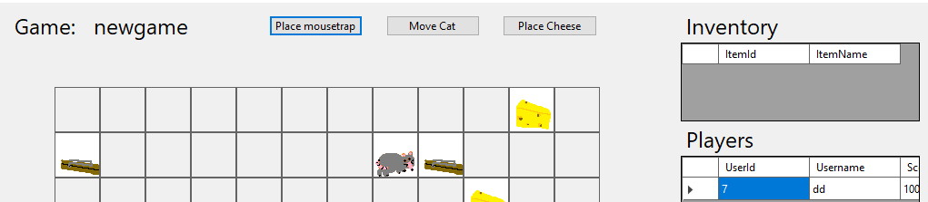

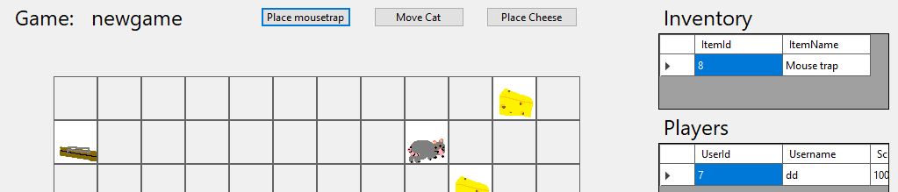

8. Move an Item (NPC effect).

The move cat button moves the cat to a random adjacent tile by calling the MoveCat method in the GameDAO, in the future version this will also happen on a timer.

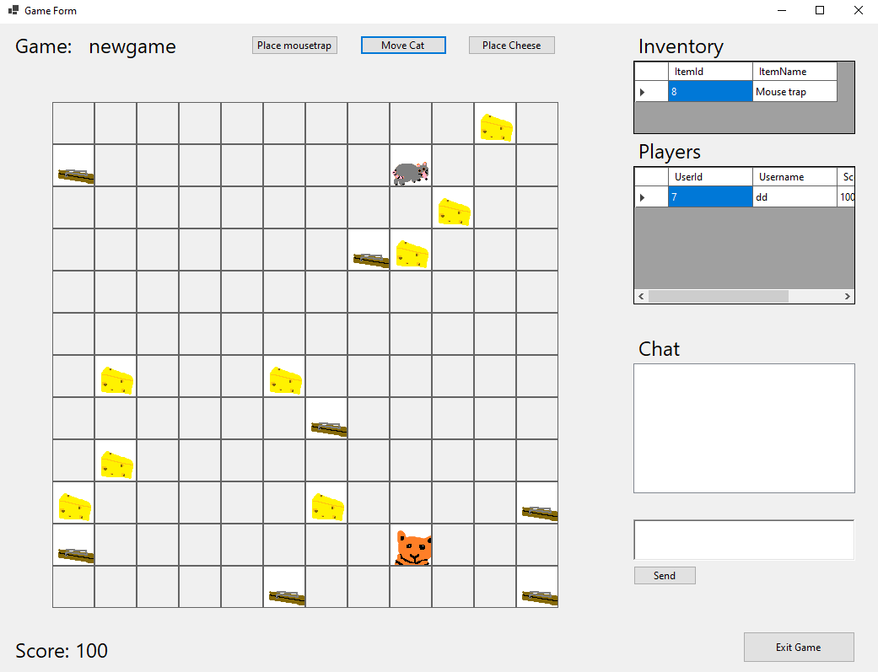

9. Kill running games.

Games can be killed from the Manage Games form in the admin tools by selecting the game and clicking the ‘Kill Game’ button. This button calls the KillGame method in the AdminDAO and passes it the ID of the selected game

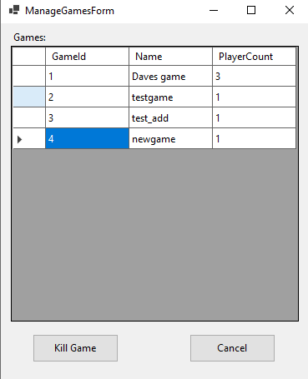

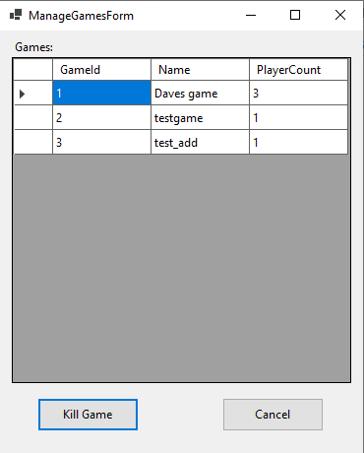

10. Add new players.
When a player joins a game, the AddPlayer method within GameDAO is called. The method is passed the user ID of the player and the game ID of the game they are joining.

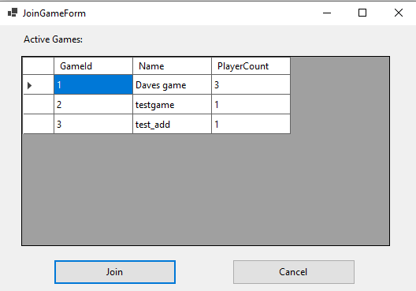

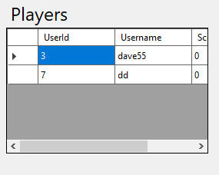

Admins can add users with the add users button. This just opens a registration form which makes the Registration method call within AdminDAO discussed earlier

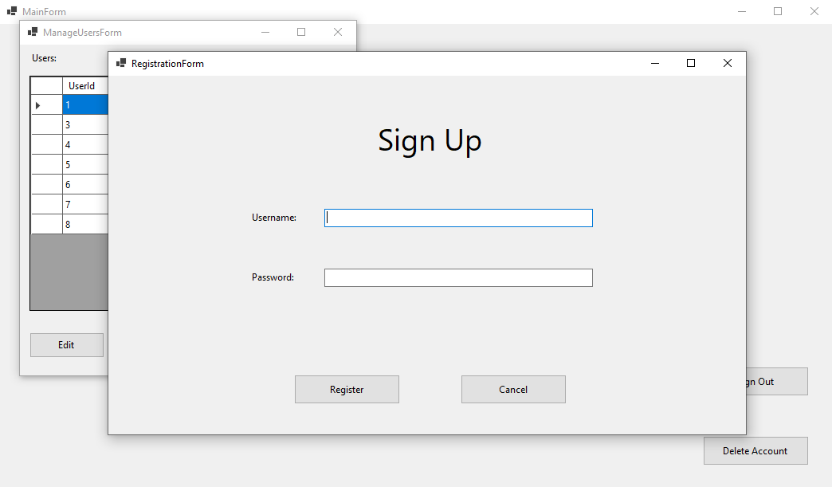

11. Update data of a player.

The edit button within the manage users form allows an admin to edit a players username

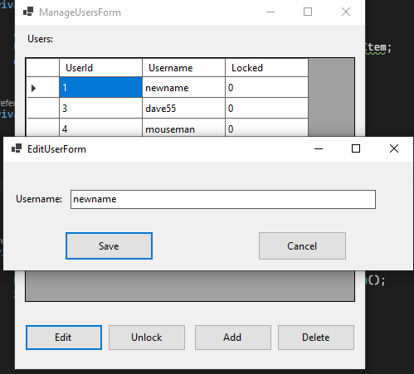

Clicking save calls the UpdateUser method within AdminDAO and passes it the user ID of the User as well as the new username

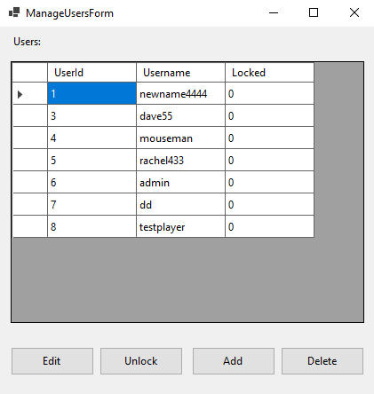

The players username is then updated

12. Delete a player.

Clicking the delete button within the manage users form allows an admin to delete a player by calling DeletePlayer from the AdminDAO. This method is passed the user ID of the selected user in order to delete them.

